**Kerd**

1. **Objectives and Outcomes**
2. **Rules**
3. Player Turns
4. Board Setup and Initial Positions of the Pieces
5. Infiltration
6. Board Regions
7. Water
8. Land
9. Air
10. **Pieces**
11. Pawn
12. Commander Pawn
13. Bishop
14. Scout
15. Hussar
16. Jumper
17. Tower
18. Queen
19. King

**Created by**

Cem CEYLAN

Ege ALTIOK

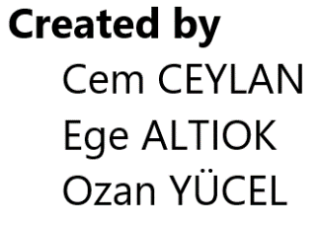Ozan YÜCEL

# Objectives and Outcomes

* The objective for both players is to attack opponent’s King in a situation where the opponent has no legal move to make in his/her turn. In this case the opponent is considered as “mated” and has lost the game.
* If the opponent’s King is not being attacked but he/she has no legal move to make in his/her turn, the game is drawn.

*White to Move Black to Move (White Wins) Black to Move (Draw)*

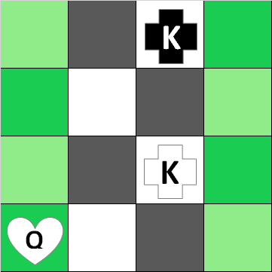 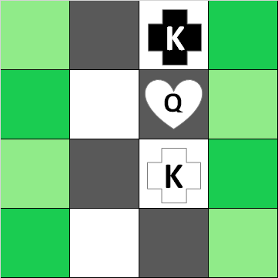 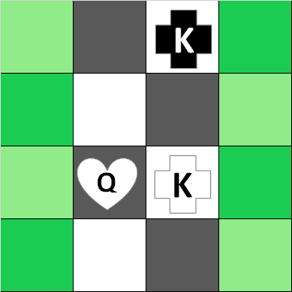

# Rules

## Player Turns

* The player who sits the table first has the right to choose which color he/she will play.
* Player with the white pieces makes the first move.
* After a player makes his/her move, the turn is passed to the opponent.

## Board Setup and Initial Positions of the Pieces

* Board is composed of 12x12 squares that orthogonally alternated light and dark colors.
* The initial position of the pieces is as the following:

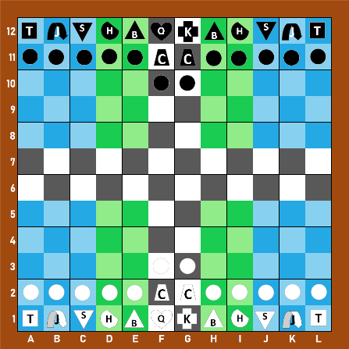

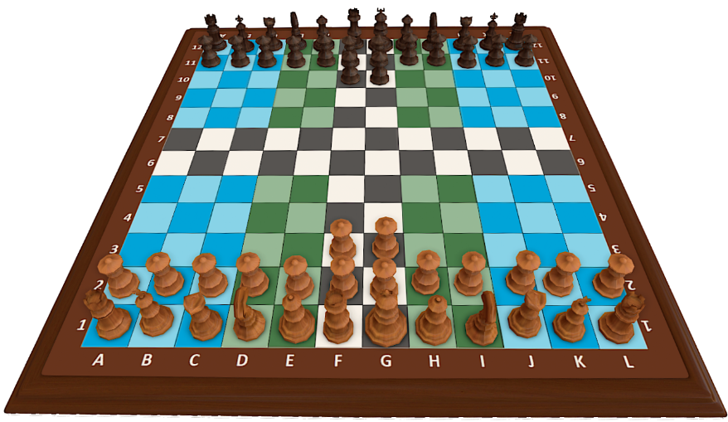

## Infiltration

* At the start of the game, each player chooses an enemy piece as the infiltrator and writes it on a piece of paper. Then, they both put the papers face-down on the table.
* The King, the Queen, Rooks, and Scouts cannot be chosen as infiltrators.
* Infiltrator pieces can only be revealed after one of the players has checked his opponent.
* The turn ends after a player reveals his infiltrator piece.
* After an infiltrator piece is revealed, it changes its color and its side.
* If a player suspects one of his/her pieces as the infiltrator, he/she can execute (remove) that piece and pass the turn to the opponent. Players cannot know if the executed piece is infiltrator or not.

## Board Regions

1. 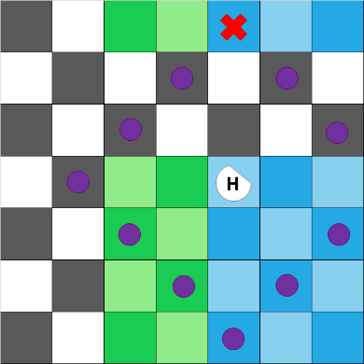**Water**

* Pawns can be moved by only one square on their first move.
* A piece that is in this region cannot move to a square if it enters and leaves an air segment on the way. Scouts, Towers, and the Queen are not affected by this rule.

1. 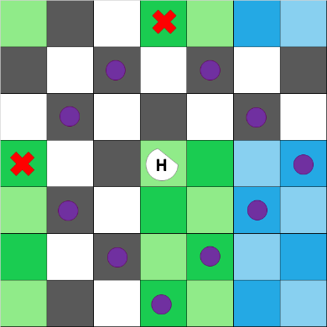**Land**

* Pawns can be moved by one or two squares on their first move.
* A piece that is in this region cannot move to a square if it enters and leaves an air segment on the way. Scouts, Towers, and the Queen are not affected by this rule.

1. 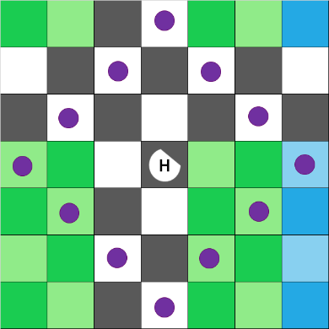**Air**

* Pawns can be moved by one, two or three squares on their first move.
* A piece that is in this region can move to a square on any region.

# Pieces



1. 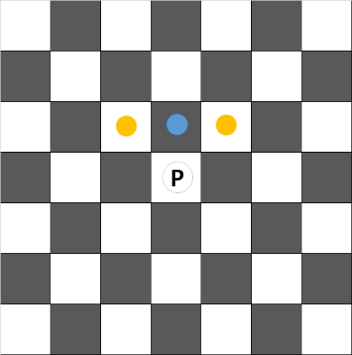**Pawn

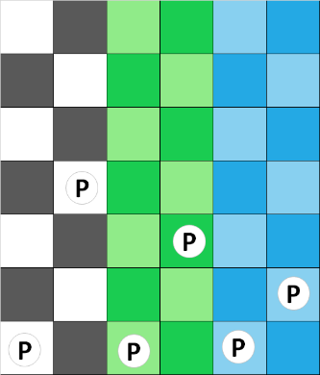

* Moves one square forward vertically.
* Captures one square forward diagonally.
* Can make a special move depending on its region on its first move.
* Can be “promoted” on indicated squares as shown below.

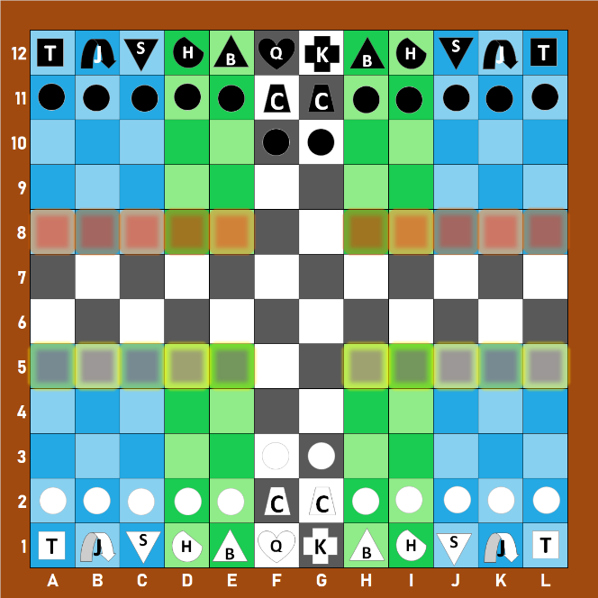

* When a pawn leaves the air region, it can be used to bring back a piece that was removed from the board.
* The piece that has been brought back takes place of the pawn that was used in the process.
* White’s pawn promotion squares are highlighted with red.
* Black’s pawn promotion squares are highlighted with yellow.

1. 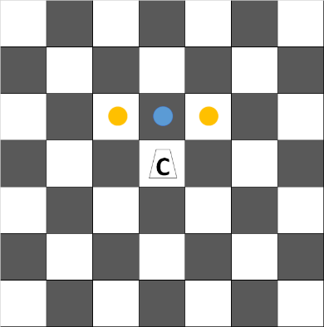**Commander Pawn

* Moves and captures like normal pawns.
* Can attach on a pawn around and move with it.
* If the attached pawn cannot move as far as the commander pawn, they can only move as far as the attached pawn does.
* If a pawn (other than a commander pawn) is captured on any square around this piece, the commander pawn can recapture on that square.

*Special Move Example 1 Special Move Example 2 Recapturing with Special Move*

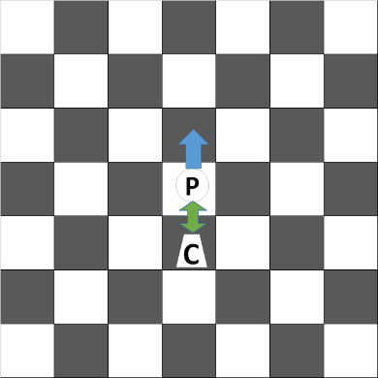 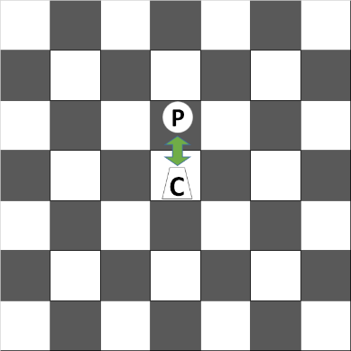 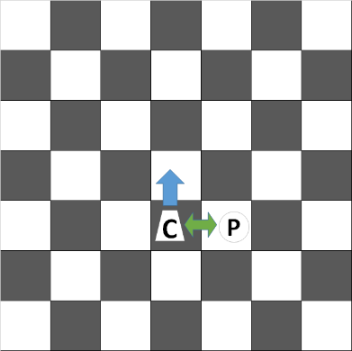 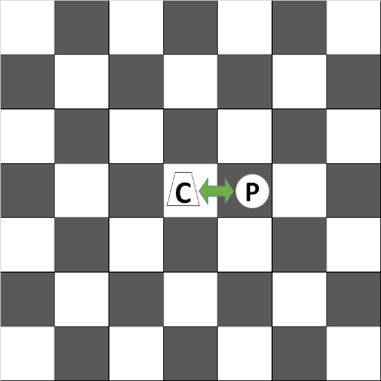 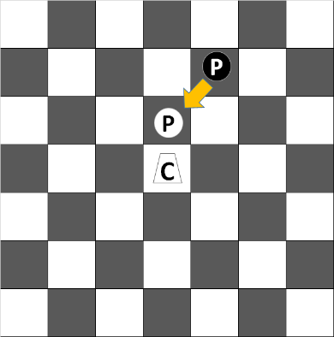 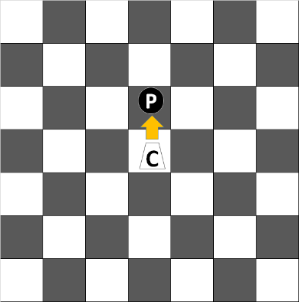

## Bishop

* Moves and captures diagonally to any square if it follows the region rules.

*Normal Moves on Air Normal Moves on Land*

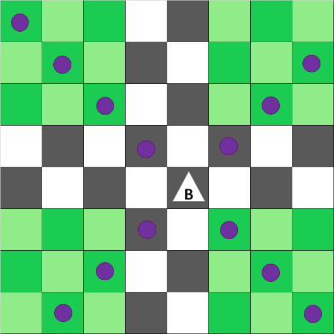 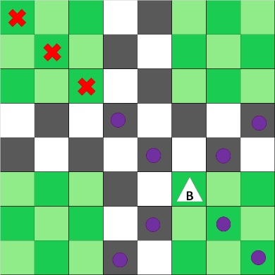

## Scout

* Moves and captures like bishops.
* Is not affected by regions as mentioned in the rules.

*Normal Moves on Air Normal Moves on Any Other Region*

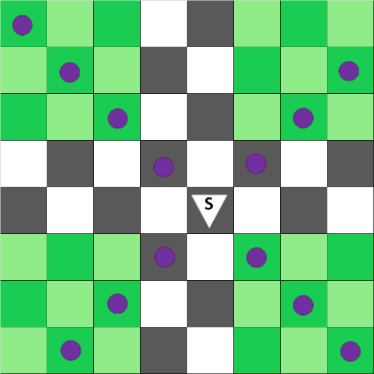 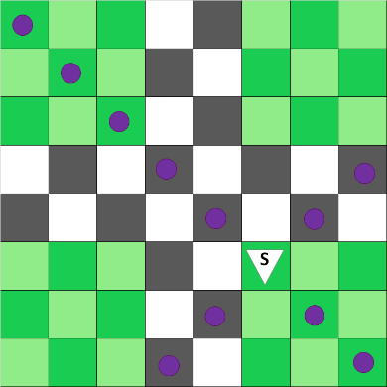

## Hussar

* Moves and captures two squares vertically and one square horizontally, or two squares horizontally and one square vertically, or three squares orthogonally.
* If it jumps over an enemy piece, it cannot move or capture three squares orthogonally.

*Normal Moves Special Condition*

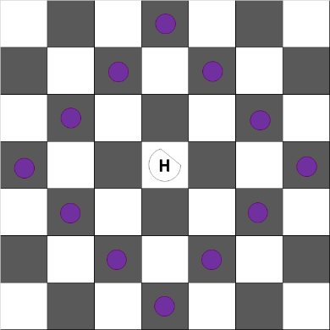 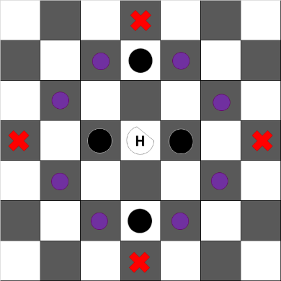

## Jumper

* Moves one square to any direction.
* Captures on one square forward diagonally or one square forward vertically.
* Can jump over a friendly or enemy piece if there is no piece behind it.
* Is affected by regions. This piece's jump ranges are *[0, 1, and 2]* on *[water, land, and air]* respectively.
* After the jump, it always lands on the square next to the piece that it jumps over.

*Normal Moves*

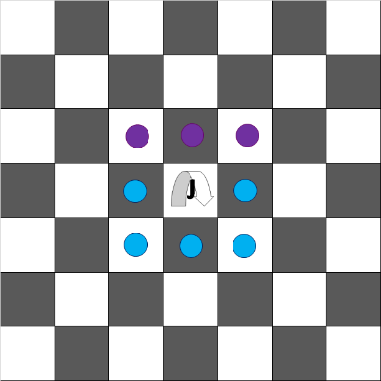

*Special Moves on Water Special Moves on Land Special Moves on Air*

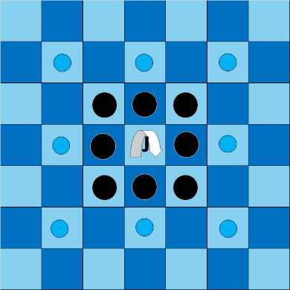 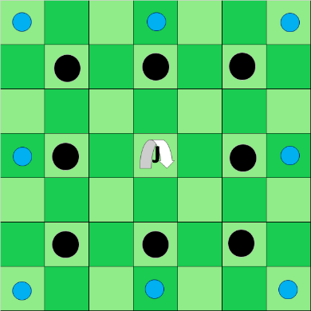 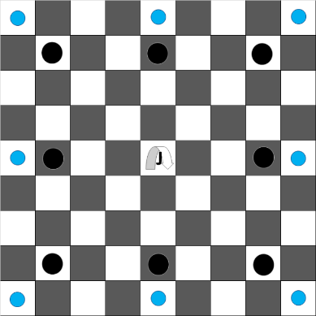

## Tower

* Moves orthogonally to any square.
* Is not affected by regions as mentioned in the rules.

*Normal Moves on Air Normal Moves on Any Other Region*

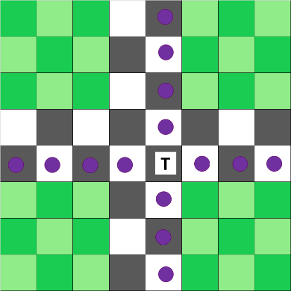 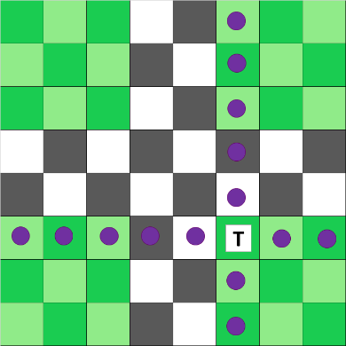

## Queen

* Moves and captures orthogonally or diagonally to any square.
* Is not affected by regions as mentioned in the rules.

*Normal Moves on Air Normal Moves on Any Other Region*

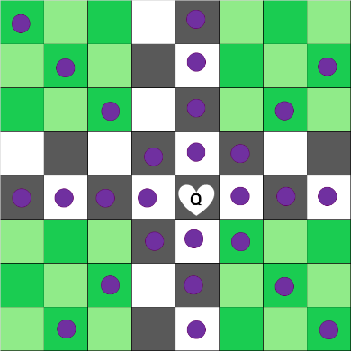 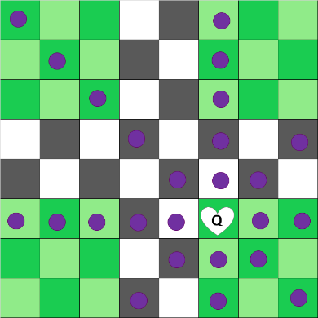

1. 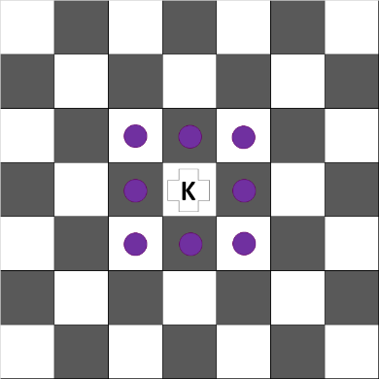**King

* Moves and captures one square orthogonally or diagonally.
* Can make a special move called “castling” if only,
  + there are no pieces between your King and either one of your Jumper pieces,
  + there are no enemy pieces attacking your King or a square on your King’s castling route.
  + your King and the Tower that you are castling with has not moved since the start of the game.
* If castling long (queenside),
  + The King moves four squares away from the center.
  + The Tower moves four squares towards the center.
* If castling short (kingside),
  + The King moves three squares away from the center.
  + The Tower moves three squares towards the center.

*Black is about to make a Long (Queenside) Castling After Black King’s Long Castling*

*White is about to make a Short (Kingside) Castling After White King’s Short Castling*

